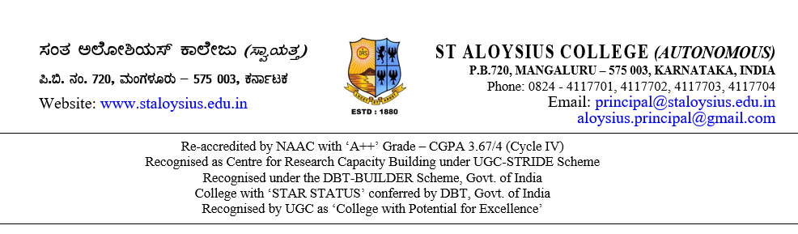

**TO WHOMSOEVER IT MAY CONCERN**

This is to certify that the following students studying in VI Semester BCA, of our College during the academic year 2022–23 has done their project on the topic titled **“_____________________________________________”** for the purpose of partial requirements for the award of the degree of Bachelor of Computer Application (BCA).

They have collected information from us and has satisfactorily completed the project under our guidance during the period from January 2023 to May 2023. During this tenure, their conduct and character was found good.

**Mr / Ms Student Name – Regno**

**Mr / Ms Student Name – Regno**

**Mr / Ms Student Name – Regno**

Thanking You,

Yours truly

(Name & Signature)

Place:

Date: